Why was the Gallipoli Campaign a failure?

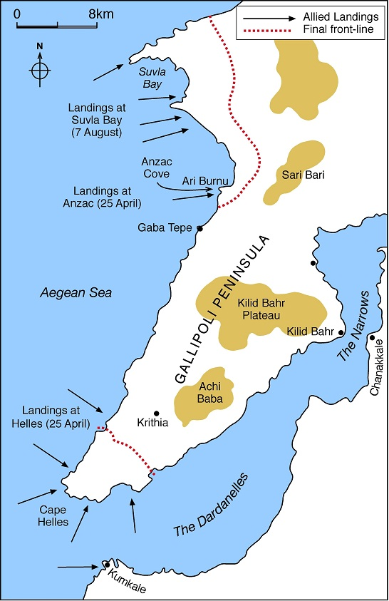
- The landings 25 April 1915
In March 1915 Royal Navy failed to seize the Dardenelles. For the plan to be successful troops would have to be used to capture the Turkish forts on the Gallipoli Peninsula. Sir Ian Hamilton, the Commander in Chief of the Mediterranean Expeditionary Forces (MEF) decided to land troops in two different places. British and French troops would land at the tip of the peninsula at Helles. From there they would attack north to link up with Australian and New Zealand Troops who landed at Anzac Cove
The landings started on April 25th. At first things went well, as the Turks lacked men to stop the landings on each beach. On three beaches the British got ashore with few casualties. But the landing at Sedd-el-Bahr soon went wrong. . Turkish troops were well dug-in and were able to kill many British soldiers before the even got off the landing barges
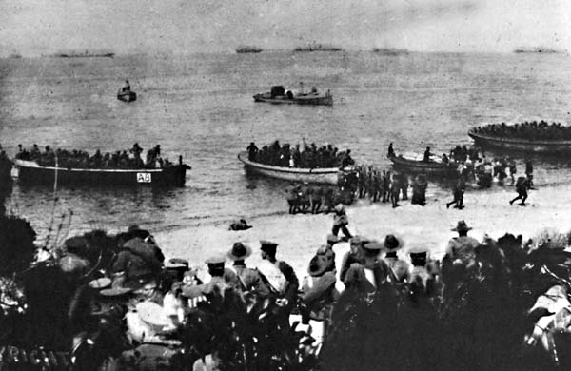
The ANZAC’s had even worse problems. Their landing beach was too small and men and equipment became congested. To get off the beach thee Anzacs had to climb steep cliffs, all the time being shot at by Turks. Although the ANZAC’s managed to push the Turks back some way they were unable to destroy their resistance.
Source 1: ANZAC landings, 25 April 1915
It soon became clear that Hamilton’s original plan had failed. Although the Turks only had 62,000 men to defend 150 miles of coastline compared to the 80,000 men available to Hamilton they had several advantages. Firstly they held the high ground making it almost impossible for the British to capture their trenches. To make
Source 2: ANZAC landings, 25 April 1915

advances was very difficult due to the geography of the peninsula. Steep ravines and gullies had to be climbed by exhausted troops. Secondly the Turks were well-led by their German Commander Liman von Sanders and the outstanding Turkish commander Colonel Mustapha Kemel. Also, the Turks fought far more bravely than the British expected. They were fighting to defend their country so were determined to stop the invaders. Finally the MEF lacked enough artillery (heavy guns) to destroy the Turkish trenches before men attacked them.

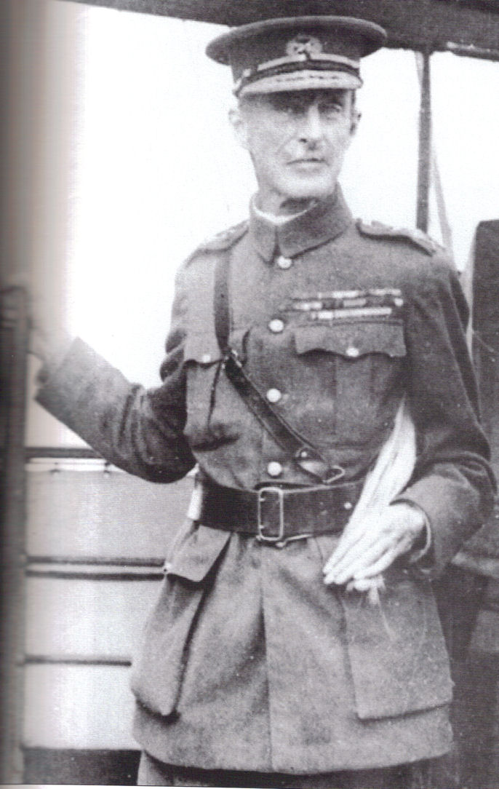
- The Battles for Krithia
The MEF had been unable to advance far inland and the first part of the attack had failed. On 28 April Hamilton ordered the first of three attacks on the village of Krithia, north of Helles. He believed that capturing the village would allow the British troops, (including the Royal Naval Division) and the French to push north and link up with the ANZACS. However, each of the three attacks (28th April, 6 May and 4th June) failed. The attack on 6 May was disastrous as a third of the British and Australian troops were killed or wounded. Hamilton did try a new tactic in his third attack by ordering his troops to crawl close to the Turkish trenches at night. He also ordered the artillery bombardment to stop and then re-start when the Turks left their shelters. The bombardment was successful in drawing out the Turkish defenders and 9000 were killed. But the British advance, including the RND still failed – 6,500 were killed and Krithia was not captured. The Turks were able to bring up reinforcements from other parts of the battlefield to prevent a breakthrough.
Source 3: Sir Ian Hamilton, Commander-in-Chief of the MEF
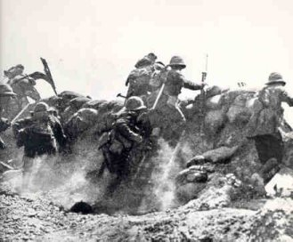

Source 4: British troops going ‘over the top’ at the Third Battle of Krithia

- The Royal Naval Division and the Third Battle of Krithia
By 29 May the Royal Naval Division was at full strength on the Gallipoli Peninsula. The Hawke, Benbow and Collingwood battalions had sailed from England in Early May. Now they were to take part in the Third Battle of Krithia, which began on 4 June.
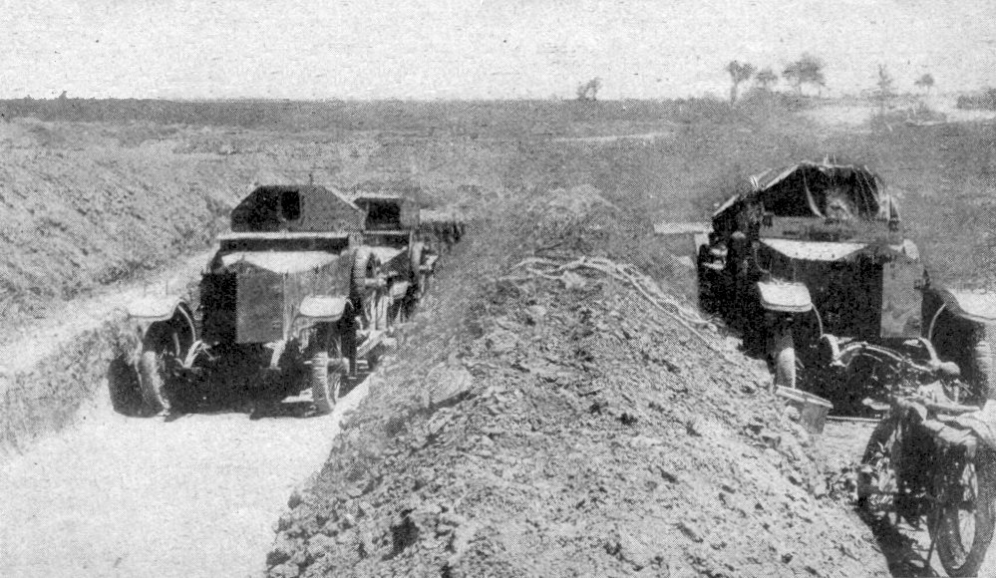
Following the bombardment the RND sent forwards its four armoured cars. These were based upon Rolls Royce Silver Ghost cars and each had a turret armed with machine guns. Their job was to clear the Turkish barbed wire before the troops tried to capture the trenches. Unfortunately the ground over which they moved was too rough. One car fell into a shell hole while the others were stopped by shell fire and machine guns.
Source 5: RND armoured cars at Gallipoli
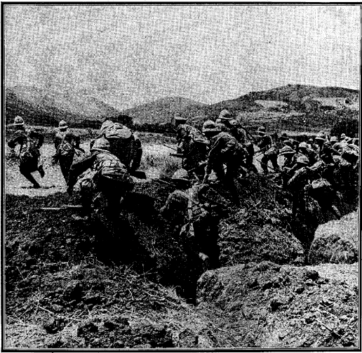
The Howe, Hood and Anson battalions had to go over the top and get through no mans land as quickly as possible. But as men climbed out of their trenches they were cut down by Turkish machine guns. The officers suffered most, as they had to lead their men forward. Half were killed or wounded almost immediately. Still the RND swept forward and they did manage to capture the Turkish front line and reserve trench. However, there were now only 20 officers and s00 men to hold the trenches against fierce Turkish counter-attacks.
Source 6: RND troops leaving their trenches

At this point the Collingwood Battalion was called forward to help the other RND troops. At 12:15 their commander order his men to advance across no-mans-land. Again they were an easy aarget for the Turkish machine guns. Only 300 men reached the first trench out of the 900 men and 26 officers who had gone ‘over the top’. This was the first time these men had gone into battle and 500 died in a matter of minutes. Only two officers were left alive. Sub-Lieutenant Denis Browne, a musician and a good friend of Rupert Brooke, was one of the men killed. Before he died of his wounds he wrote to another friend:

Source 7: From a letter by Denis Browne to Edward Marsh
I’ve gone now too: not too badly I hope. I’m luckier than Rupert because I’ve fought. But there’s no one to bury e as I buried him, so perhaps he’s best off in the long run.
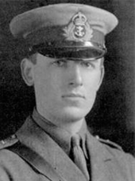

Source 8: Denis Browne

The RND continued to take part in the Gallipoli campaign throughout 1915. By October more than 4,000 men were dead or had to be sent home due to wounds or sickness. Reinforcement were sent out from Blandford Camp to replace as many men as possible.

- The August offensive – Suvla Bay
The failure of earlier battles led to a new landing at Suvla Bay in August. From there British and ANZAC troops would join together to capture the high ground to the north and east. 63,000 Allied troops landed at Suvla Bay on 6 August. The plan then involved the New Zealand troops capturing a hill called Chunuk Bair. 760 men in the New Zealand Wellington Battalion managed to reach the top but soon faced heavy Turkish counter-attacks. Eventually 711 of these men became casualties. After two days a fierce counter-attack by Mustafa Kemel forced the troops who had relieved the New Zealanders off Chunuk Bair.

At the same time the British failed to make any progress inland from Suvla.The plan to link up with the ANZAC’s also failed as the Australians could not break out of Anzac Cove. By August 10th, the Turks had retaken Suvla Bay.

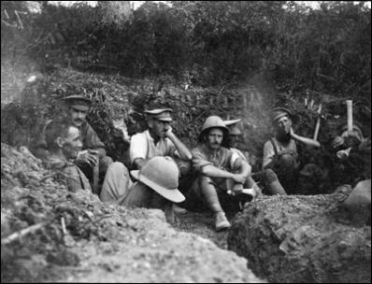

Source 9: New Zealand troops shortly before the attack on Chunuk Bair

- What were conditions like for the British and ANZAC troops?
For many men fighting at Gallipoli turned into a horrendous experience. This was not simply due to the constant fear of Turkish snipers or being ordered to attack trenches defended by machine guns. The hot summer led to plague of flies. These were huge bluebottles which covered any food immediately, making it impossible to eat. The number increased because of the amount of dead bodies on the battlefield.

Source 10: Gunner Dudey Meneaud-Lissenburg, Royal Field Artillery.

We were invaded by millions of flies. Drinking and eating was a real nightmare and I avoided no matter how hungry I was rice pudding, mixed with currants. It was difficult to distinguish the currants from flies. Immediately the lid was taken off the tine the flies would swarm down and fall into the pudding. The ceilings of our shelters, a waterproof sheet, were black with flies crawling over each other and falling on top of one as you tried to rest

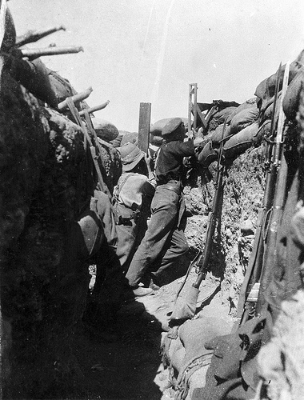
Lice were also a problem for the men. A female louse could lay 60 eggs in the seams of their uniforms These hatched in about ten days causing men to suffer terrible itching.

Food was usually in short supply. Men were given a lump of salt bacon for breakfast and a ‘hard tack biscuit’. For dinner they had tinned ‘bully beef’. But this turned to a runny mush in the heat and was soon ‘fly stew’ if it was not eaten quickly. Water was also a problem and many men suffered desperate thirst. As the Turks controlled most of the streams and well water had to be brought to the men in biscuit tins. Unfortunately the tines were made of metal which reflected the sunlight. Water carriers were often the target of Turkish snipers. For the men of the RND the daily issue of rum was something that helped to keep their spirits up. As members of the Royal Navy they were entitled to a daily ‘tot’ of rum.
Source 11: Soldiers using a trench periscope
Many men began to fall ill, with dysentery. This was a chronic form of diarrhoea which led many men to be unable to fight

- The evacuation December 1914-January 1916
The fight for Gallipoli now became bogged down in a stalemate. As winter approached the weather on the peninsula grew worse. A three day rain storm on 27 November flooded the trenches, drowning many men. Others were then killed by a blizzard in early December as they lacked winter clothing.

Hamilton’s failure meant he was sacked as Commander in Chief. The Minister for War, Lord Kitchener visited the battlefield and decided it was impossible to capture more ground without taking men from the Western Front. Kitchener was not prepared to do this and instead ordered an evacuation. Using as much secrecy as possible the troops were to leave Gallipoli . Anzac Cove and Suvla were evacuated on 19 December. Helles was evacuated on 9 January 1916. The British had failed to capture Gallipoli and force Turkey out of the war.

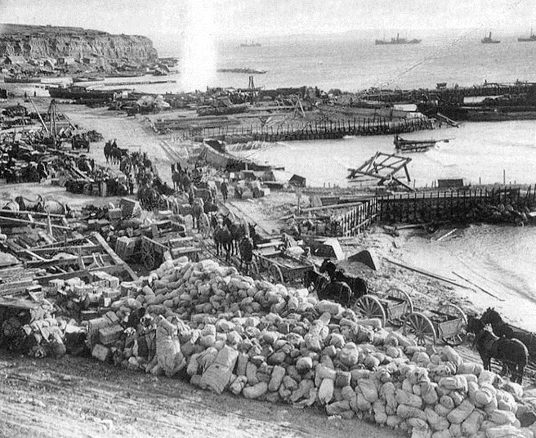
Source 12: Helles beach just before the evacuation began in December 1915.

