Blandford, the Royal Naval Division and the Gallipoli Campaign

Introduction

At the start of the First World War in 1914 the Royal Navy had nearly 30,000 reserve sailors. These men could not be found jobs on board ships. So it was decided that they could be used to form the Royal Naval Division (RND). The division was made up of eight battalions. Each battalion had about 1,000 men. They were named after famous naval commanders:
- 1st Drake Battalion
- 2nd Hawke Battalion
- 3rd Benbow Battalion
- 4th Collingwood Battalion
- 5th Nelson Battalion
- 6th Howe Battalion
- 7th Hood Battalion
- 8th Anson Battalion

Many of these men were sent to Belgium at the start of the war to stop the German advance. 80% of the men lacked basic equipment such as packs, water bottles, or mess tins. They wore sailors’ uniforms and were armed with out-of-date rifles. By early October the RND was back in England after failing to prevent the Germans from capturing the city of Antwerp.

It was decided that the RND would set up its base at Blandford on the area known as the Race Down. This area had been used as a military training site for nearly 200 years. Alongside the camp a German prisoner of war camp was set up.

Source 1: Recruitment Poster for the Royal Naval Division
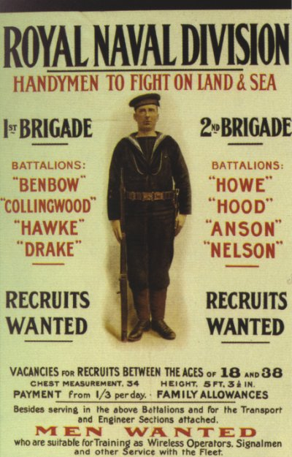

Source 2: The Hood Battalion by L. Sellers (1993)

The first Royal Naval Division troops arrived in Blandford on 27 November 1914. The camp consisted of wooden huts in three main groups. Each group contained 16 outer huts in two lines of eight, between– mainly living units for 16, 14 or 12 men. The camp was to be self-contained and huts for the YMCA, post office, Methodist Church, Church of England and medical area were provided, in addition to canteens.

Because of its exposed position Blandford Camp was considered one of the healthiest training camps in the country, although the men had a different view. For bed and bedding they were issued with two trestles and three boards, two blankets and a straw-filled mattress – hardly luxury. Each hut had a coke stove, but these were inefficient and let out fumes.

Training consisted of drill, marching, digging trenches, mock attacks and general battlefield situations. Joseph Murray of the Hood Battalion says they were instructed ‘to lie down in the mud, mud up to your eyebrows, which was a whitish soil, but you had to be spick and span on parade the next day’. Camp routine was run on navy lines. A ship’s bell kept the watches; leaving camp was to go ashore and being late in returning was being adrift.

In December 1914, all officers and men were issued with active service uniforms in khaki, instead of their former naval blues. The naval brigades retained a naval-style hat, but in khaki, with a band around it showing the name of their battalion in gold at the front. Later pith helmets were issued. Overall discipline and efficiency improved as their greatly improved and distinctive appearance led to rivalry between the different battalions and brigades.

Source 3: RND men under the railway arches in Blandford

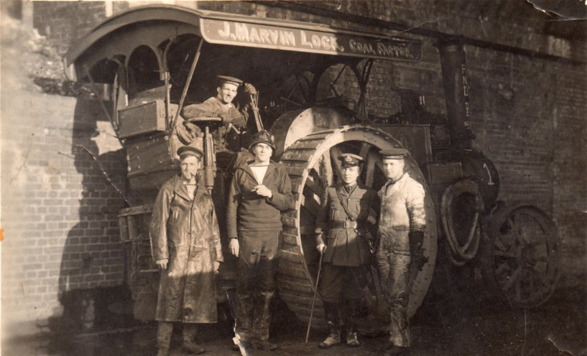

Source 4: A postcard on sale at Blandford Camp in 1914 contained this ‘poem’ (edited version)

What a happy place is Blandford
Envied by all soldiers near and far
Oh my heart always inclines
To the good old A1 lines,
Oh what a merry lot they are.

We’ve a rather mixed collection in the Blandford RND,
For we’ve got 5,000 sailors who have never seen the sea,
And we’ve got a naval transport of 500 horse-marines,
The express design of Winston to supply the Turks with beans.
Oh what a happy place is Blandford,
Such a jolly place to war,
But if you’ve ever been to sea,
Gad, you’d love the RND.
Oh what a lucky lot you are.

Oh they feed like lords at Blandford, on delicious bully beef.
They don’t know what it died of, but suppose it died of grief,
For thinking of the men who’ve got to eat its tawny flesh,
But is better than tinned salmon when the salmon isn’t fresh.

Source 5: from a letter written by Lieutenant Patrick Shaw-Stewart, February 1915

I have been marching literally 15 miles a day for all last week bar two days, and once 20, and once 18, so I am if possible, more in the pink of condition than ever, and very proud of the condition of my feet. The stokers on the other hand have very many blisters, poor souls, and complain bitterly that they aren’t on the nice comfy sea.

Source 6: Rupert Brooke describing a visit on 17 February 1915 by Winston Churchill

What a day! A real Blandford day of the milder kind, mud, rain and a hurricane. Winston (Churchill) turned up and demanded something. We were hurried out to an unplanned performance, plunging through rivers and morasses. It was like a dream. At one point I emerged from the mud, with my platoon, under the wheels of a car, in the midst of a waste.

Rupert Brooke and Blandford

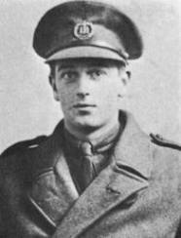
Probably the most famous member of the RND was the poet, Rupert Brooke. He was born on 3 August 1887 and his father was a housemaster at the famous public school, Rugby. After leaving Cambridge University he moved to the village of Grantchester, near Cambridge, where he began to write his first book of poetry. During his lifetime Brooke was admired for both his brains and beauty. Another poet, W. B. Yeats once described Brooke as "the handsomest man in England".

At the start of the war in 1914 Brooke was keen to fight, believing that Belgium had to be defended against German aggression. Winston Churchill arranged for Brooke and his friend, the musician Denis Browne, to become officers in the newly formed Royal Naval Division. Brooke and Browne took part in the disastrous defence of Antwerp in October 1914. On return they were sent to the new RND camp at Blandford. When Brooke was not training, he wrote poems. The most famous of these was one called ‘The Soldier’.

In February 1915, he set sail with the RND for the Dardanelles. On board ship he developed septicaemia from a mosquito bite on his lip. He died on 23 April 1915 on a hospital ship off the Greek island of Skyros and was buried in an olive grove on the island.

The Soldier
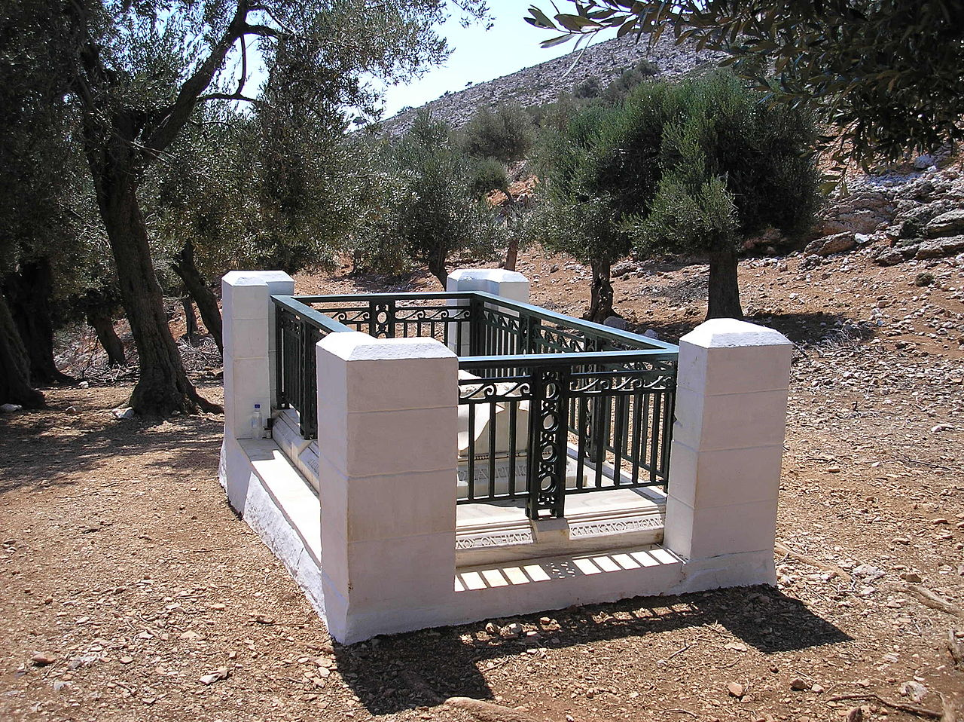
If I should die, think only this of me:
That there's some corner of a foreign field
That is forever England. There shall be
In that rich earth a richer dust concealed;
A dust whom England bore, shaped, made aware,
Gave, once, her flowers to love, her ways to roam,
A body of England's, breathing English air,
Washed by the rivers, blest by the suns of home.
And think, this heart, all evil shed away,
A pulse in the eternal mind, no less
Gives somewhere back the thoughts by England given;
Her sights and sounds; dreams happy as her day;
And laughter, learnt of friends; and gentleness,
In hearts at peace, under an English heaven.
Rupert Brooke’s grave on the Greek island of Skyros.

Source 6 : From a letter by Rupert Brooke sent to Violet Asquith (the Prime Minister’ after learning that the RND was to be sent to the Dardanelles

Oh, Violet, it’s too wonderful for belief. I had not imagined fate could be so kind….I am filled with confident and glorious hopes. Shall we be a turning a point in history? I’ve never been quite so happy; like a stream flowing entirely to one end.

Source 7: The Hood Battalion by L. Sellers (1993)
On 25 February the King, George V turned up at Blandford to inspect the men. Churchill along with his wife, Clementine and the Prime Minister’s daughter, Violet Asquith also were present. Violet Asquith described Churchill as glowing with pride in his troops. The division returned past his majesty, then gave the king three cheers and the bands played the national anthem. At 7.15 pm on 28 February the division marched out of camp in pith helmets, with the rain pouring down. They marched 10 miles to Shillingstone railway station.

Source 8: From a letter written by Reverend Henry Foster
Our last day in camp was 27 February and in the afternoon of that day a large number of relations and friends assembled on the parade ground to bid us ‘God speed’. The bands were playing national songs, the most popular being For Auld Lang Syne. How little did we realize that many fathers and mothers were saying goodbye to their brave your sons for the last time. And yet we tried to ‘keep smiling’, and to look on the bright side, but it was difficult.

(At Shillingstone there) was a long tedious wait, but our comfort had not been forgotten. Lady Baker, who lived close to Blandford had arranged for a number of ladies to run a canteen in the vicinity of the station. Here a plentiful supply of hot coffee proved to be a Godsend to us all. Our train left at 3.30 am on Sunday 28 February, and we took off our equipment and boots and had a good sleep in the carriage. It was eight o’clock when we awoke in the morning, to find ourselves at Avonmouth Docks, Bristol.

Source 9: RND men shortly before departure to the Dardanelles
