Blandford, the Royal Naval Division and the Gallipoli Campaign

Introduction

At the start of the First World War in 1914 the Royal Navy had nearly 30,000 reserve sailors. These men could not be found jobs on board ships. So it was decided that these men could be used to form the Royal Naval Division (RND).

Many of these men were sent to Belgium at the start of the war to stop the German advance. They wore sailors’ uniforms and were armed with out-of-date rifles. By early October the RND was back in England after failing to prevent the Germans from capturing the city of Antwerp.

It was decided that the RND would set up its base at Blandford on the area known as the Race Down. This area had been used as a military training site for nearly 200 years. Alongside the camp a German prisoner of war camp was set up.

Source 1: Recruitment Poster for the Royal Naval Division
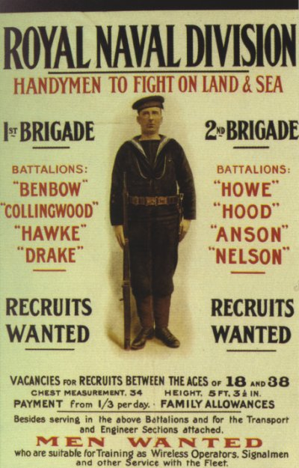

Source 2: The Hood Battalion by L. Sellers (1993)

The first Royal Naval Division troops arrived in Blandford on 27 November 1914. The camp consisted of wooden huts for 16, 14 or 12 men. The camp also had huts for canteens medical services and churches.

The men didn’t find the camp to be very comfortable. For bed and bedding they were issued with, two blankets and a straw-filled mattress – hardly luxury. Each hut had a coke stove, but these let out fumes.

Training consisted of drill, marching, digging trenches and mock attacks. Camp routine was run on navy lines. A ship’s bell kept the watches; leaving camp was to go ashore and being late in returning was being adrift.

In December 1914, all officers and men were issued with new uniforms in khaki, instead of their former naval blues. They still had a naval-style hat, but in khaki, with a band around it showing the name of their battalion. Later pith helmets were issued.

Source 3: RND men under the railway arches in Blandford

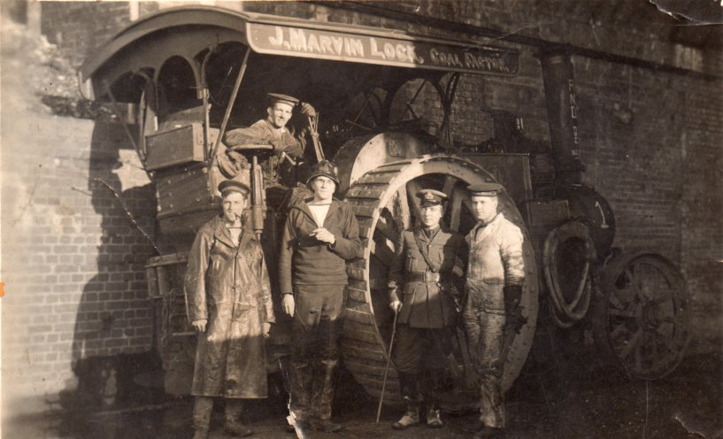

Source 4: A postcard on sale at Blandford Camp in 1914 contained this ‘poem’ (edited version)

What a happy place is Blandford
Envied by all soldiers near and far
Oh my heart always inclines
To the good old A1 lines,
Oh what a merry lot they are.

We’ve a rather mixed collection in the Blandford RND,
For we’ve got 5,000 sailors who have never seen the sea,
And we’ve got a naval transport of 500 horse-marines,
The express design of Winston to supply the Turks with beans.
Oh what a happy place is Blandford,
Such a jolly place to war,
But if you’ve ever been to sea,
Gad, you’d love the RND.
Oh what a lucky lot you are.

Oh they feed like lords at Blandford, on delicious bully beef.
They don’t know what it died of, but suppose it died of grief,
For thinking of the men who’ve got to eat its tawny flesh,
But is better than tinned salmon when the salmon isn’t fresh

Source 5: from a letter written by Lieutenant Patrick Shaw-Stewart, February 1915 (edited version)

I have been marching 15 miles a day for all last week bar two days. I am if possible, more in the best condition than ever, and very proud of the condition of my feet. The stokers (seamen) on the other hand have very many blisters, poor souls, and complain bitterly that they aren’t on the nice comfy sea.

Source 6: Rupert Brooke describing a visit on 17 February 1915 by Winston Churchill (edited version)

What a day! A real Blandford day of the milder kind, mud, rain and a hurricane. Winston (Churchill) turned up and demanded a show. We were hurried out to an unplanned performance, plunging through rivers and morasses. It was like a dream. At one point I emerged from the mud, with my platoon, under the wheels of a car.

Rupert Brooke and Blandford

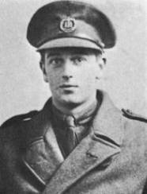
Probably the most famous member of the RND was the poet, Rupert Brooke. He was born on 3 August 1887. After leaving Cambridge University he began to write his first book of poetry. During his lifetime Brooke was admired for both his brains and beauty. Another poet, W. B. Yeats once described Brooke as "the handsomest man in England".

At the start of the war in 1914 Brooke was keen to fight. Winston Churchill arranged for Brooke and his friend the musician, Denis Browne, to be to become officers in the Royal Naval Division. At the end of 1914 He was sent with his men to the new RND camp at Blandford. When Brookes was not training, he wrote poems. The most famous of these was one called ‘The Soldier’.

In February 1915, he set sail with the RND for the Dardanelles. On board ship he was bitten on the lip by a mosquito. As a result he developed blood poisoning. He died on 23 April 1915 on a hospital ship off the Greek island of Skyros and was buried on the island.

The Soldier
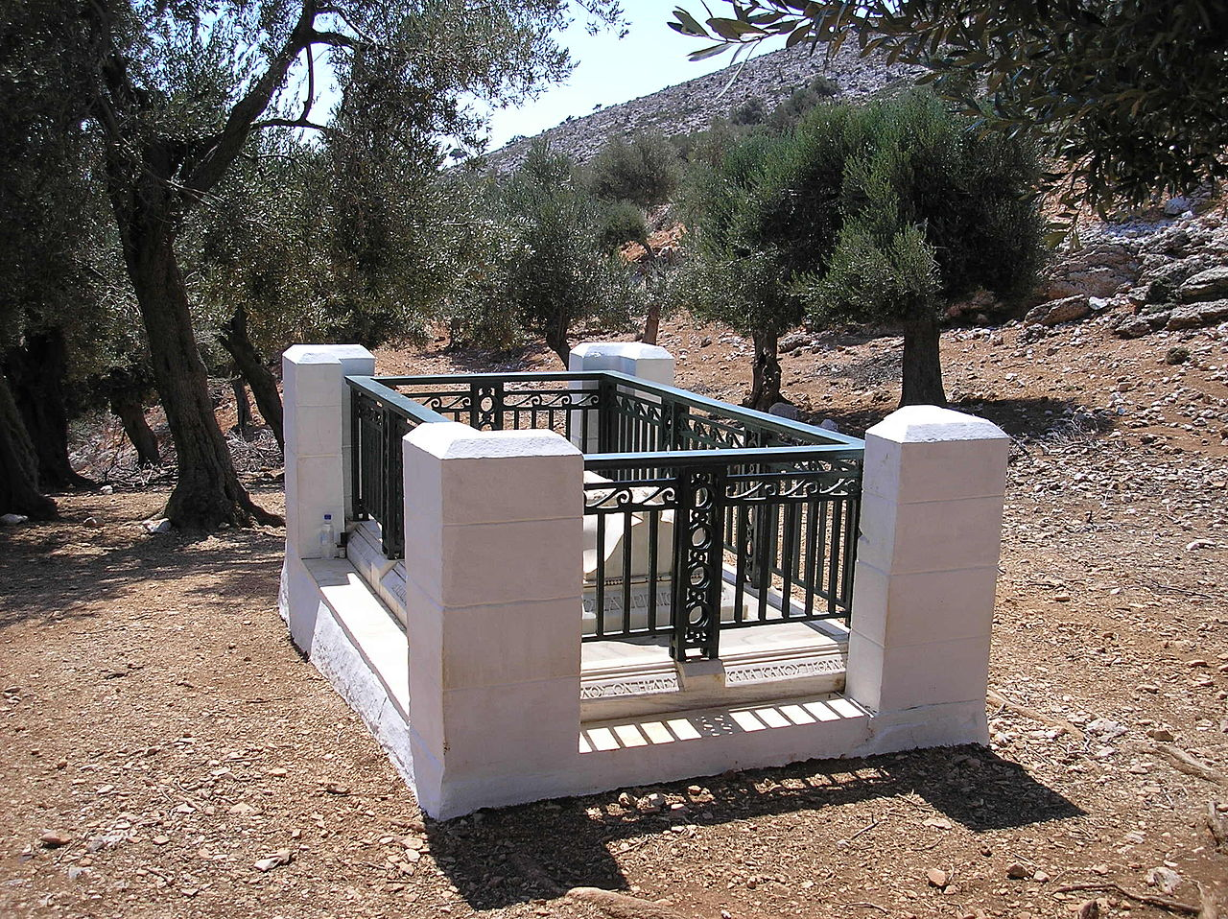
If I should die, think only this of me:
That there's some corner of a foreign field
That is forever England. There shall be
In that rich earth a richer dust concealed;
A dust whom England bore, shaped, made aware,
Gave, once, her flowers to love, her ways to roam,
A body of England's, breathing English air,
Washed by the rivers, blest by the suns of home.
And think, this heart, all evil shed away,
A pulse in the eternal mind, no less
Gives somewhere back the thoughts by England given;
Her sights and sounds; dreams happy as her day;
And laughter, learnt of friends; and gentleness,
In hearts at peace, under an English heaven.
Rupert Brooke’s grave on the Greek island of Skyros.
Rupert Brooke

Source 7: From a letter by Rupert Brooke sent to Violet Asquith (the Prime Minister’s daughter) after learning that the RND was to be sent to the Dardanelles
Oh, Violet, it’s too wonderful for belief. I had not imagined fate could be so kind…. I am filled with confident and glorious hopes. Shall we be a turning a point in history? I’ve never been quite so happy.

Source 8: The Hood Battalion by L. Sellers (1993)
On 25 February the King, George V turned up at Blandford to inspect the men. Churchill along with his wife, Clementine and the Prime Minister’s daughter, Violet Asquith also were present. The division marched past his majesty, then gave the king three cheers and the bands played the national anthem. At 7.15 pm on 28 February the division marched out of camp, with the rain pouring down. They marched 10 miles to Shillingstone railway station.

Source 9: From a letter written by Reverend Henry Foster (edited version)

Our last day in camp was 27 February and in the afternoon of that day a large number of relations and friends assembled. How little did we realise that many fathers and mothers were saying goodbye to their brave your sons for the last time. And yet we tried to ‘keep smiling’, and to look on the bright side, but it was difficult.

(At Shillingstone there) was a long boring wait, Our train left at 3.30 am on Sunday 28 February, and we took off our equipment and boots and had a good sleep in the carriage. It was eight o’clock when we awoke in the morning, to find ourselves at Avonmouth Docks, Bristol.

Source 10: RND men shortly before departure to the Dardanelles
