What is the connection between Blandford,
the Royal Naval Division and Gallipoli?

Aims
- To research the connection between Blandford and the Royal Naval Division
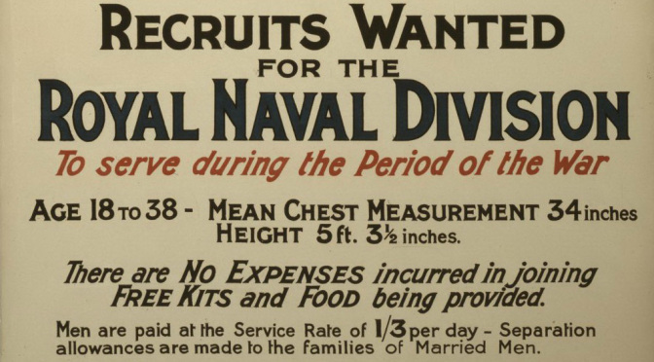
- To produce a leaflet to be available in the town museum to explain to visitors the connection

Key questions / answers
1

2

3

4

5

6

7

8

